

**Advance e-Commerce**

A Software Project Submitted

By

|  |  |  |  |  |
| --- | --- | --- | --- | --- |
| sr | Name | Id | Email | Phone |
| 1 | Borno, Md. Sirajuddin | 18-36449-1 | [bornoahmed2@gmail.com](mailto:bornoahmed2@gmail.com) | 01704992725 |
| 2 | Hossain, Muntasir | 18-36421-1 | [muntasirhosain@gmail.com](mailto:muntasirhosain@gmail.com) | 01788075438 |
| 3 | Abdullah, Syed | 18-36537-1 | [syed_khoab@outlook.com](mailto:syed_khoab@outlook.com) | 01744-641522 |
| 4 | Faisal, Mahbub Hossain | 18-37337-1 | [mahbubhossain249@gmail.com](mailto:mahbubhossain249@gmail.com) | 01966272734 |

Under the supervision of

**Abhijit Bhowmik**

Associate Professor

Department of Computer Science

Faculty of Science and Technology

American International University Bangladesh

Summer Semester 2020-2021

**Disclaimer**

This is to certify that this project is our original work. No part of this has been submitted elsewhere partially or fully for the award of any other degree. Any material reproduced in this project has been properly acknowledged.

________________________________________

1. Name: Borno, Md. Sirajuddin

ID No: 18-36449-1

________________________________________

2. Name: Hossain, Muntasir

ID No: 18-36421-1

________________________________________

3. Name: Abdullah, Syed

ID No: 18-36537-1

________________________________________

4. Name: Faisal, Mahbub Hossain

ID No: 18-37337-1

**Approval**

The Software Project or Project titled “**Advance e-commerce**” has been submitted to the following respected members of the Board of Examiners of the Faculty of Science and Technology in partial fulfillment of the requirements for the degree of Bachelor of Science in Software Engineering on 29th July 2021 by the following students and has been accepted satisfactory.

|  |  |
| --- | --- |
| ____________________________  **Abhijit Bhowmik**  Associate Professor & Supervisor  Department of Computer Science  American International University- Bangladesh | ____________________________  **Dr. Md. Mahbub Chowdhury Mishu**  Head(Undergraduate)  Department of Computer Science  American International University- Bangladesh |
| ____________________________  **Professor Dr. Tafazzal Hossain**  Dean in Charge  Faculty of Science & Technology American International University-Bangladesh | **Dr. Carmen Z. Lamagna**  Vice Chancellor  American International University-Bangladesh |

**Acknowledgements**

We would like to take the chance to express our gratitude to our honorable teacher & Supervisor Abhijit Bhowmik, for his continuous guidance and support regarding this report. Besides this, we have found so many sincere and productive advices from many people that we would like pay homage to them. We convey our gratitude to our honorable Vice Chancellor, Dr. Carmen Z. Lamagna for encouragement.

Table of Contents

**Chapter 1: Statement of Work** 7

**1.1** **Purpose/Objectives** 7

1.2 **Scope** 7

1.3 **Proposed System** 7

1.4 **System Features** 8

1.5 **Environment** 9

1.5.1 **Organizations Involved** 9

1.5.2 **Processing** 10

1.5.3 **Security** 10

1.6 **Assumptions** 11

1.7 **Constraints** 11

1.8 **Proposed System** 12

1.8.1 **Description/Improvements of Proposed System** 12

1.8.2 **Resources** 13

**1.8.3** **Hardware** 13

1.8.4 **Software** 13

1.8.5 **Operating Environment** 14

1.9 **Project Time & Cost** 14

1.9.1 **Project Period** 14

1.9.2 **Project Schedule** 14

1.9.3 Domain & Hosting Package 15

**Chapter 2: Software Requirement Specification** 17

2. 1 **Introduction** 17

2.1.1 **Objectives and Scope** 17

2.1.2 **Document Convention:** 17

2.1.3 **References** 17

2.2 **Overall Description** 18

2.22 **User classes and characteristics** 18

2.2.3 **Operating Environment** 18

2.2.4 **Design and implementation constraints** 18

2.3.1 **Description of feature** 19

2.3.2 **Functional requirements** 21

2.3.3 **User Stories (user requirements)** 22

2.4 **External Interface Requirements** 23

**Chapter-3: Diagram** 33

3.1 **Use Case Diagram** 33

**Chapter-4: Software Project Management Plan** 45

4.1 **Document History and Distribution** 45

4.1.1 **Revision History** 45

4.1.2 **Distribution** 45

4.2 **Overview** 45

4.2.1 **Purpose, Objectives and Project Scope** 45

4.2.2 **Project Scope** 46

4.2.3 **Assumptions and Constraints** 46

4.3 **Project Deliverables** 46

4.3.1 **The list of project deliverables is** 46

4.3.2 **Schedule and Budget Summary** 46

4.4 **Evolution of the Software Project Management Plan** 47

4.4.1 **Definitions** 47

4.5 **Project Organization** 47

4.5.1 **External Interfaces** 47

4.5.2 **Internal Structure** 48

4.5.3 **Roles and Responsibilities** 48

4.6 **Managerial Process Plans** 48

4.6.1 **Project Start-up Plan** 48

4.6.2 **Estimation Plan** 48

4.6.3 **Staffing Plan** 49

4.6.4 **Resource Acquisition Plan** 49

4.6.5 **Project Staff Training Plan** 49

4.7 **Work Plan** 49

4.7.1 **Budget Allocation** 49

4.8 **Control Plan** 50

4.8.1 **Requirements Control Plan** 50

4.8.2 **Schedule Control Plan** 50

4.8.3 **Budget Control Plan** 50

4.8.4 **Quality Control Plan** 50

4.8.5 **Reporting Plan** 51

4.8.6 **Metrics Collection Plan** 51

4.9 **Risk Management Plan** 51

4.10 **Closeout Plan** 53

4.11 **Technical process plans** 53

4.12 **Process Model** 53

4.13 **Methods, Tools and Techniques** 53

4.14 **Infrastructure Plan** 53

4.15 **Product Acceptance Plan** 54

4.16 **Supporting Process Plans** 54

4.17 **Configuration Management Plan** 54

4.18 **Verification and Validation Plan** 55

4.19 **Documentation Plan** 55

4.20 **Quality Assurance Plan** 55

4.21 **Reviews and Audits Plan** 55

4.22 **Problem Resolution Plan** 55

4.23 **Subcontractor Management Plans** 56

4.24 **Process Improvement Plan** 56

**REFERENCES** 56

# **Chapter 1: Statement of Work**

## **Purpose/Objectives**

Mainly in Dhaka city where people are doing their job and can’t find enough time to go to the grocery store every week to buy their groceries. Who goes shopping most of the time goes without a proper shopping list and spends more than they need. So our main purpose is to provide them the service where they can get their necessary groceries from their homes. Our service also restricts them from over spending. They will only spend the amount of money for their groceries that they can afford.

Customers can always edit the suggestion based on their needs. Then customers can order those products online. We will deliver products weekly. The best part is customers can make payments monthly and they can choose a specific time limit on a specific day of the week when s/he wants the delivery (e.g. 7 pm-9 pm, Monday).

## 1.2 **Scope**

The scope of this project is to study and design a web application that will provide services to busy families. Deliver products within fixed days of weeks and in a time range. Deliver fresh vegetables and groceries regularly. The scope of the project is much specified as it outlines the modern e-commerce to be incorporated in individual business models. This project is carried out to build a web based e-commerce application from scratch. Our intelligent system will provide all the suggestions of grocery lists based on customer budget.

## 1.3 **Proposed System**

This web-application is built to provide service to the customers to get their needful day to day groceries. The system will provide a suggestion of a grocery list based on their budget that will be for a month. They will be able to order their needs and they can also customize their orders. They don't need to go outside to purchase their groceries, they can just order from the website. Customers will provide their preferred order receive date and time and the system will automatically place orders for the customers. If the customer wants they can also change their preferences time and date and they will also have the authority to cancel their order at any time.

Benefits /Improvements of Proposed System

* No hassle for buying groceries.
* Customers will set their monthly budget and the system will provide a suggestion list of groceries.
* Customers don't have to go outside to get their groceries.
* Customers don't need to spend time thinking about grocery shopping.
* It prevents customers from overspending on groceries.
* Customer satisfaction.
* Save time and travelling cost.
* Very safe and secure payment system.
* Multiple option for doing payment.
* Every transaction history is recorded.

## 1.4 **System Features**

Admin:

* Login
* Add new admin and managers
* View Retailer and delivery man information
* View customer information

HR Manager:

* Login
* Retailer verification
* Delivery man verification

Accounting and Finance:

* Login
* Manage Income and expenditure

Customer:

* Login
* View product
  + By shop
  + By category
  + Search
  + Sort
  + Suggestion List
* Grocery suggestion list
* Add to cart
* Checkout
  + Make payment (Mobile banking, Card) once in a month
  + View balance (adjustment with previous balance)
  + Service cancelation (Entirely)
* Order Cancelation (Weekly/Monthly)
* Feedback on product and delivery service (optional)
* Discounts/Voucher/Referrals
* View stats (Monthly, Category)

Unregistered User:

* See/search contents (groceries)
* Check availability of products
* See available offers.

Retailer:

* Self-Registration
* Retailer info
  + Shop name
  + Shop Address
  + Bank account information
  + Verification
* Add/Update/Disable Product
* Discount/Voucher
* View Review and ratings
* Update delivery information

Delivery Man:

* Self-Registration
* Verification
* Login
* View nearest order
* Accept order
* Update delivery process
* View Stats
* View Review and ratings

Payment:

* Keeping log of all transaction history.
* Individual client wise payment module.
* Security and authentication verification of payment cards.

## 1.5 **Environment**

## 1.5.1 **Organizations Involved**

Project Client: ABHIJIT BHOWMIK.

Developer: AB-15 Team

User: Online Users or Customers

## 1.5.2 **Processing**

* This application will be worked as a website which will be supported by any web browser.
* It will be also platform independent. For example, it will work on windows, Linux and mac-OS or any other platform.
* If it gather proper recognition it will also be available as mobile applications on mobile platforms like android or IOS.
* This website will have four working modules. Admins, Users, Retailers and Deliverymen will have their individual workings.
* All the information of the users, retailers and deliverymen will be stored in the website. Admins as well as users, retailers and deliverymen also can see their information’s in the website.
* Login system will be authenticated for everyone.
* The data transmission inside the website will be secured by maintaining data security policies.
* All the transactional data of the users and retailers will be kept secured and private

## 1.5.3 **Security**

System’s security requirements

* User authentication will be required to login to the website. If the user is new they can sign up by giving valid information.
* Without signing up and being verified, retailers or deliverymen can’t use the features of the website but can view products.
* Customers can view website but cannot make purchase without registration.
* Without a secured login, there will be no transaction happen
* Authority can have the right of removing any deliverymen account from the website if they want.
* Users and retailers data will be kept protected

## 1.6 **Assumptions**

Some third party software may be used to build this project. These are free components, most of which are open source. We have used Google Chrome, Microsoft New Edge, etc. as web browsers to access the user interface as client applications. Then our project will not be affected because we have not used anything used illegally.

## 1.7 **Constraints**

Usage without maintaining regulation: Data will be passed from client to server through TCP/IP & we are not using any public key encryption service like SSL certificate right now. But we have plan to add this when the site will reach a large number of users. So we can have risks or errors in case of passing user data. It may cause – Confidentiality, Integrity and security problems. Only registered users, retailers and deliverymen are valid & can use the software through Client Application with help of Internet Browser on server side. For any missing password found by anonymous user, responsibility goes to valid user. They have to follow the rules and regulations for a secure usage of the website.

* **Bandwidth limitations**: The internet speed is different and depends on area to area. So user satisfaction of using the website will also fluctuate for slow speed of internet. Then it may also lose server connection for technical error (depends on hardware/internet connection). We need to run query again. But we will work to ensure the best user experience in a limited bandwidth.
* **Databases**: We will use MySQL database for the backend of the website. When user queries will be more than server limitations, we need to check the databases and refresh the data tables by running query again.
* **Parallel operations**: Parallel use of other Internet applications like having several tabs open in the browser where other applications are using the users bandwidth may hamper the proper loading of the website features or may take longer time for a response of a query as the internet becomes slower.
* **Language requirements**: Language will be used in this software is C#. Because we will use Asp.net to create this website which is a framework of C#. We may also use JavaScript if it became necessary to build the frontend.
* **Communications protocols**: Communication protocols we are using- TCP/IP to interact with the server. Other protocol is not considerable if user wants.
* **Security considerations**: If user doesn’t want to buy SSL security then client applications will not using any public key encryption service like SSL certificate (i.e.128 bit RSA encryption). So we have constraints in case of passing user data. It may cause (In case of internet security

**Authentication problem**: Server may not recognize/confirm actual valid user.

**Confidentiality problem**: User, intended server fails “understanding” message contents.

**Integrity problem**: sender, server may fail to ensure message not altered without detection

**Eavesdrop**: There may be Intercept messaging, actively insert messages into connection

**Impersonation**: can fake (spoof) source address in packet (or any field in packet)

**Hijacking**: “take over” ongoing connection by removing sender or server, inserting himself in place

**Denial of service**: prevent service from being used by others (e.g., by overloading resources)

## 1.8 **Proposed System**

## 1.8.1 **Description/Improvements of Proposed System**

* Gather information of client experience about the software
* Provide map facility so that user can track the delivery man
* All the features offer almost bug free functionality
* Fast transaction
* Reduce loading time of the website and it’s features specially the heavy ones
* Reduce the making cost of the software
* More security features (data encryption, verification)
* Make the vulnerable feature strong by providing proper logic and utility tools
* Monitor system performance for taking further decisions about features that need more efficiency.
* A proper system design to make the software as much as error and bug free
* Make site responsive so that mobile or tab users can also get a better view and have great experience with the website

## 1.8.2 **Resources**

All the resource needed is provided below.

## **Hardware**

* Minimum requirements for server:

• CURL Library

• Dual Intel Xeon E5-2650 V3

• At Least 64 GB RAM per Server

• Language Support

• PHP 5.6 & 7.2 (w/Zend Optimizer ™)

• ImageMagick Support

• WAP/WML/Wireless Support

• MySQL 5.7+/MariaDB 10+

• Ready-to-use apps with one click

• Sites stays online and loads faster

• Perl 5.8+ (w/Free Module Installation)

• GD Graphics Library

* Minimum requirements for client:

A System than can run a Web browser.

## 1.8.4 **Software**

* Microsoft visual studio
* Entity-framework
* Adobe XD
* Microsoft SQL server
* Draw.io

## 1.8.5 **Operating Environment**

The system will be created under windows operating system environment. It will work as a middleware between the software and the operating system.

The hosting server has a 99.9% uptime. This website is platform independent.

So this will work in every platform like windows, Linux and MacOS. This

Website will be available in a variety of browsers including Chrome, Mozilla Firefox, Microsoft Edge, Opera, and others. This is a web application in which client program includes browser-based user interfaces while the major component of the website is hosted on a Linux server.

## 1.9 **Project Time & Cost**

## 1.9.1 **Project Period**

Expected time of completion of project is 4 months.

## 1.9.2 **Project Schedule**

|  |  |
| --- | --- |
| **Term** | **Description** |
| **BA** | **Business Analyst** |
| **PM** | **Project Manager** |
| **D** | **Developer** |
| **QT** | **Quality Tester** |

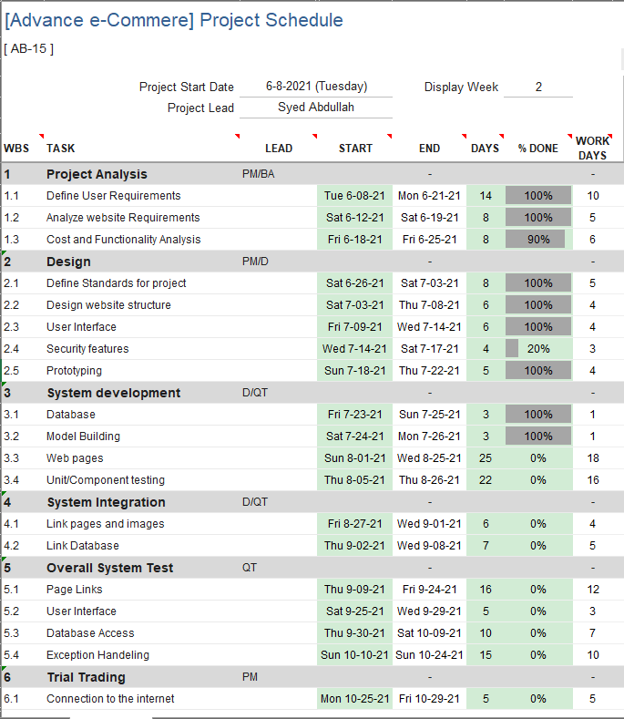

## 1.9.3 Domain & Hosting Package

**Domain**

* **.com** 1099 taka/year

**Hosting Package**

* Bandwidth: unlimited
* Storage : unlimited
* Domain pointer : unlimited
* SQL DB : unlimited
* INode :75000
* Up time: 99%

**Estimated service cost**

|  |  |
| --- | --- |
| **Description** | **Cost Assumption** |
| Resource buying | 20,000BDT |
| Site launch (hosting) | 45,000 BDT |
| Maintenance (1 year) | 30,000 BDT |
| Developers | 3,20,000 BDT |
| **Grand total** | **4,15,000 BDT** |

# **Chapter 2: Software Requirement Specification**

## 1 **Introduction**

## 2.1.1 **Objectives and Scope**

Mainly in Dhaka city where people are doing their job and can’t find enough time to go to the grocery store every week to buy their groceries. Who goes shopping most of the time goes without a proper shopping list and spends more than their need. That’s why we are offering a smart web service that can suggest them make a proper shopping list based on 3 parameters. (i) Number of a family member, (ii) Monthly budget, (iii) Based on previous shopping stats. Customers can always edit the suggestion based on their needs. Then customers can order those products online. We will deliver products weekly. The best part is customers can make payments monthly and they can choose a specific time limit on a specific day of the week when s/he wants the delivery (e.g. 7 pm-9 pm, Monday). This way customers can save time and save themselves from overspending.

**Project Scope**: The scope of this project is to study and design a web application that will provide services to the busy families. Deliver products within fixed days of weeks and in a time range. Deliver fresh vegetables and groceries regularly.

## 2.1.2 **Document Convention:**

Font family: Calibri (Body)

Font size: 11

Font color: Gray 80%, text 1, lighter 25%

## 2.1.3 **References**

1. <https://www.daraz.com.bd/>

2. <https://evaly.com.bd/>

3. <https://dhamakashopping.com/>

4. <https://www.foodpanda.com.bd/>

## 2.2 **Overall Description**

**2.2.1.** Productive perspective: Design a website for e-commerce where retailer will show products and customers will buy them. Customers will order products and delivery man will bring the products to the customers. This web application will sale products and services but in bit different way. This application will have several users.

## 2.22 **User classes and characteristics**

|  |  |
| --- | --- |
| User Class | Characteristics |
| Admin | Register new Admin or Managers. Monitor business stats and make business deals. |
| Managers | HR manager to verify new delivery mans and new retailers. They also manage their deals.  Accounting and Finance Manager to handle money flow of the business. They also monitor whole market place and where to invest, what offer to run for promotions. |
| Tech support | Tech Support team develop and maintain website and mobile application. Provide updates and upgrades. |
| Customer | Customers will buy services and products from this business. |
| Delivery man | Deliver man will deliver products to customers. |
| Retailer | Retailers will provide products to be delivered. |
|  |  |

## 2.2.3 **Operating Environment**

This system will be developed on Windows10 based Desktops. There will be a web application to run on all platforms and mobile application Android and IOS will be developed in future.

## 2.2.4 **Design and implementation constraints**

To design this website ASP.NET framework will be used. Programing Language is C# to develop backend, for database MS SQL server will be used. For front end bootstrap, CSS, HTML will be used.

Version:

|  |  |
| --- | --- |
| Application and API | version |
| Visual Studio | 2019 |
| ASP.NET framework | 4.5 |
| MS SQL Server | 18.8 |
| HTML | 5 |
| CSS | 3 |
| Bootstrap | 4 |

**2.3 System Features**

## 2.3.1 **Description of feature**

**Admin:**

1. Login
2. Add new admin and managers
3. View Retailer and delivery man information
4. View customer information

**HR Manager:**

1. Login
2. Retailer verification
3. Delivery man verification

**Accounting and Finance:**

1. Login
2. Manage Income and expenditure

**Customer:**

1. Self-Registration
2. Login
3. Customer Info

* Add Monthly Income
* Number of family members (specify adult and children)
* Monthly expenditure on grocery (range of amount)*
* Address
* Number of delivery in a month (2/4 per month)
* Number of delivery for Vegetables/Fruits (2-3 in a week)
* Preferable delivery day and time*

      3. View product

* By shop
* By category
* Search
* Sort
* Suggestion List*

        4. Add to cart

      5. Checkout

      6. Make payment (Mobile banking, Card)*

      7. View balance

      8.   Service cancelation (Entirely)

      9. Order Cancelation (Weekly/Monthly)

     10.  Feedback on product and delivery service (optional)

     11.  Discounts/Voucher/Referrals

     12. View stats (Monthly, Category)

**Retailer:**

1. Self-Registration
2. Retailer info
   1. Shop name
   2. Shop Address
   3. Bank account information
   4. Verification
3. Add/Update/Disable Product
4. Discount/Voucher
5. View Review and ratings
6. Update delivery information

**Delivery Man:**

1. Self-Registration
2. Verification
3. Login
4. View nearest order
5. Accept order
6. Update delivery process
7. View Stats
8. View Review and ratings

## 2.3.2 **Functional requirements**

* + The customers shall be able to login to the system “if they are not registered then the system shall provide a registration form for registration”.
  + The customer shall be able to get a suggestions of groceries based on their monthly expenditure “If they want to customize grocery list then the system shall provide e customization option”.
  + The customer shall be able to customize their cart product list before 24 hours.
  + The customer shall be able to order products “If they want to cancel order at any time the system shall provide an option to cancel the order”.
  + The customer shall be able to checkout order “If they don’t checkout before 24 hours then the system will done the order process automatically”.
  + The customer shall be able to select payment method from the system.
  + The customer shall be able to give rating and feedback to specific products.
  + The customer shall be able see the stats based on their history of purchases.
  + The customers shall be able to apply vouchers and discount on payment section.
  + The admin shall be able to register new admin or managers to the system.
  + The HR manager shall be able to verify new retailer and deliveryman.
  + The HR manager shall be able to see human resource management stats.
  + The accountant manager shall be able to manage Income and expenditure.
  + The retailer shop shall be able to register to the system.
  + The retailer shop shall be able to update products to the system.
  + The retailer shop shall be able to see review and ratings of their shop.
  + The retailer shop shall be able to update delivery information.
  + The retailer shop shall be able to add products to the site.
  + The deliveryman shall be able self-register himself to the system.
  + The delivery man shall be able to find order based on location.
  + The deliveryman shall be able to see and update the delivery status of order.
  + The delivery man shall be able see his/her ratings and reviews.

## 2.3.3 **User Stories (user requirements)**

|  |  |
| --- | --- |
| **Sample Use Case** | **Corresponding User Story** |
| Manager registration | As an Admin I want to register new manager so that they can maintain our system. |
| Verify retailer and delivery man | As a manager I want to verify Retailer and delivery man so that in future our system can track them and customer can get better service. |
| Customer Registration | As a customer I want to register my profile into this platform so that I can buy product. |
| Update customer profile | As a customer I want to update my profile so that future purchases are billed to updated information. |
| Order product and cancelation | As a customer I want to order product on my given information and if I don’t want to order then I will cancel my own. |
| Feedback on product and service | As a customer I want to give feedback on product and service so that in future another customer can take decision on purchasing. |
| Customer profile statistics | As a customer I want to view my daily/weekly/monthly statistics so that I can be updated. |
| Retailer Registration | As a retailer I want to register my account so that I can sell product. |
| Update Product | As a retailer I want to update, delete or insert new product into my shop to get customer and keep my shop status updated; |
| Review And Ratings | As a retailer I want to see my shop review that given by customer to solve what type of fault I have done. |
| Delivery Information | As a Retailer I want update delivery information so that customer can get updated about their product. |
| Delivery Man registration | As a delivery man I want create my account so that I can deliver product. |
| Find Order | As a delivery man I want to find customer order to deliver it properly. |
| Delivery Information | As a delivery man I want update delivery information so that customer can get updated about their product. |
| View Statistics | As a delivery man I want see how many delivery I have done. |
| Review And Ratings | As a delivery man I want to see my review that given by customer to solve what type of fault I have done. |

## 2.4 **External Interface Requirements**

2.4.1 **User interface**

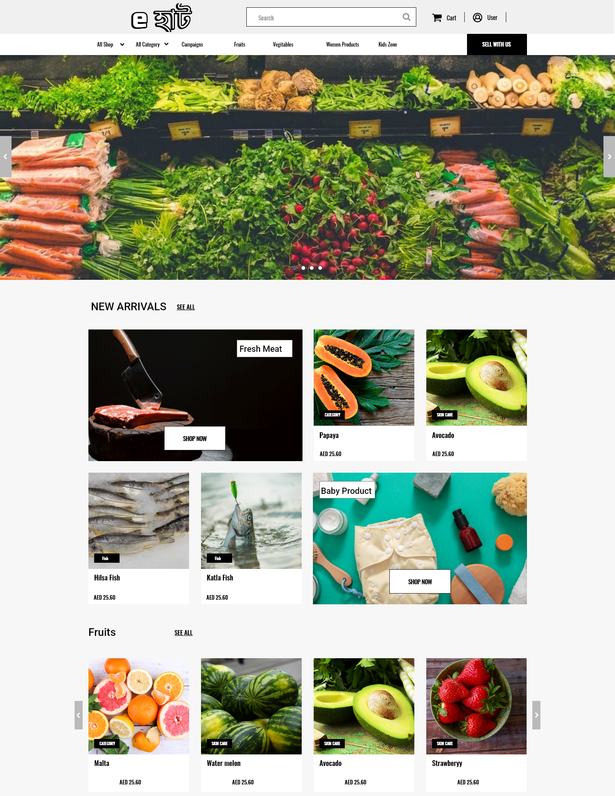**Home page:**

**Sign in/ registration**

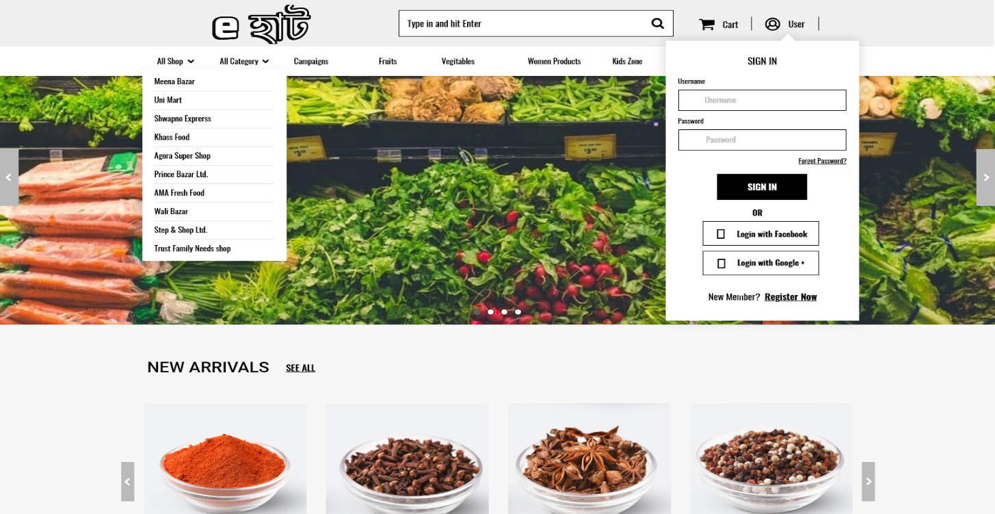

**Product Details**

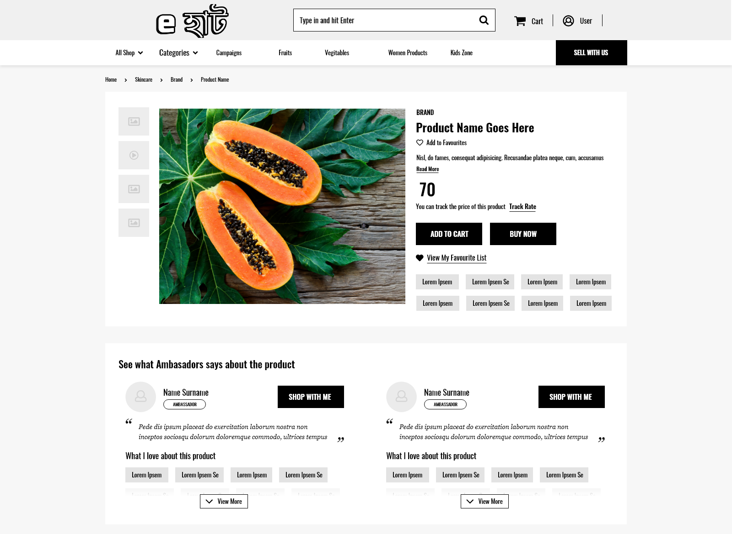

**Product review**

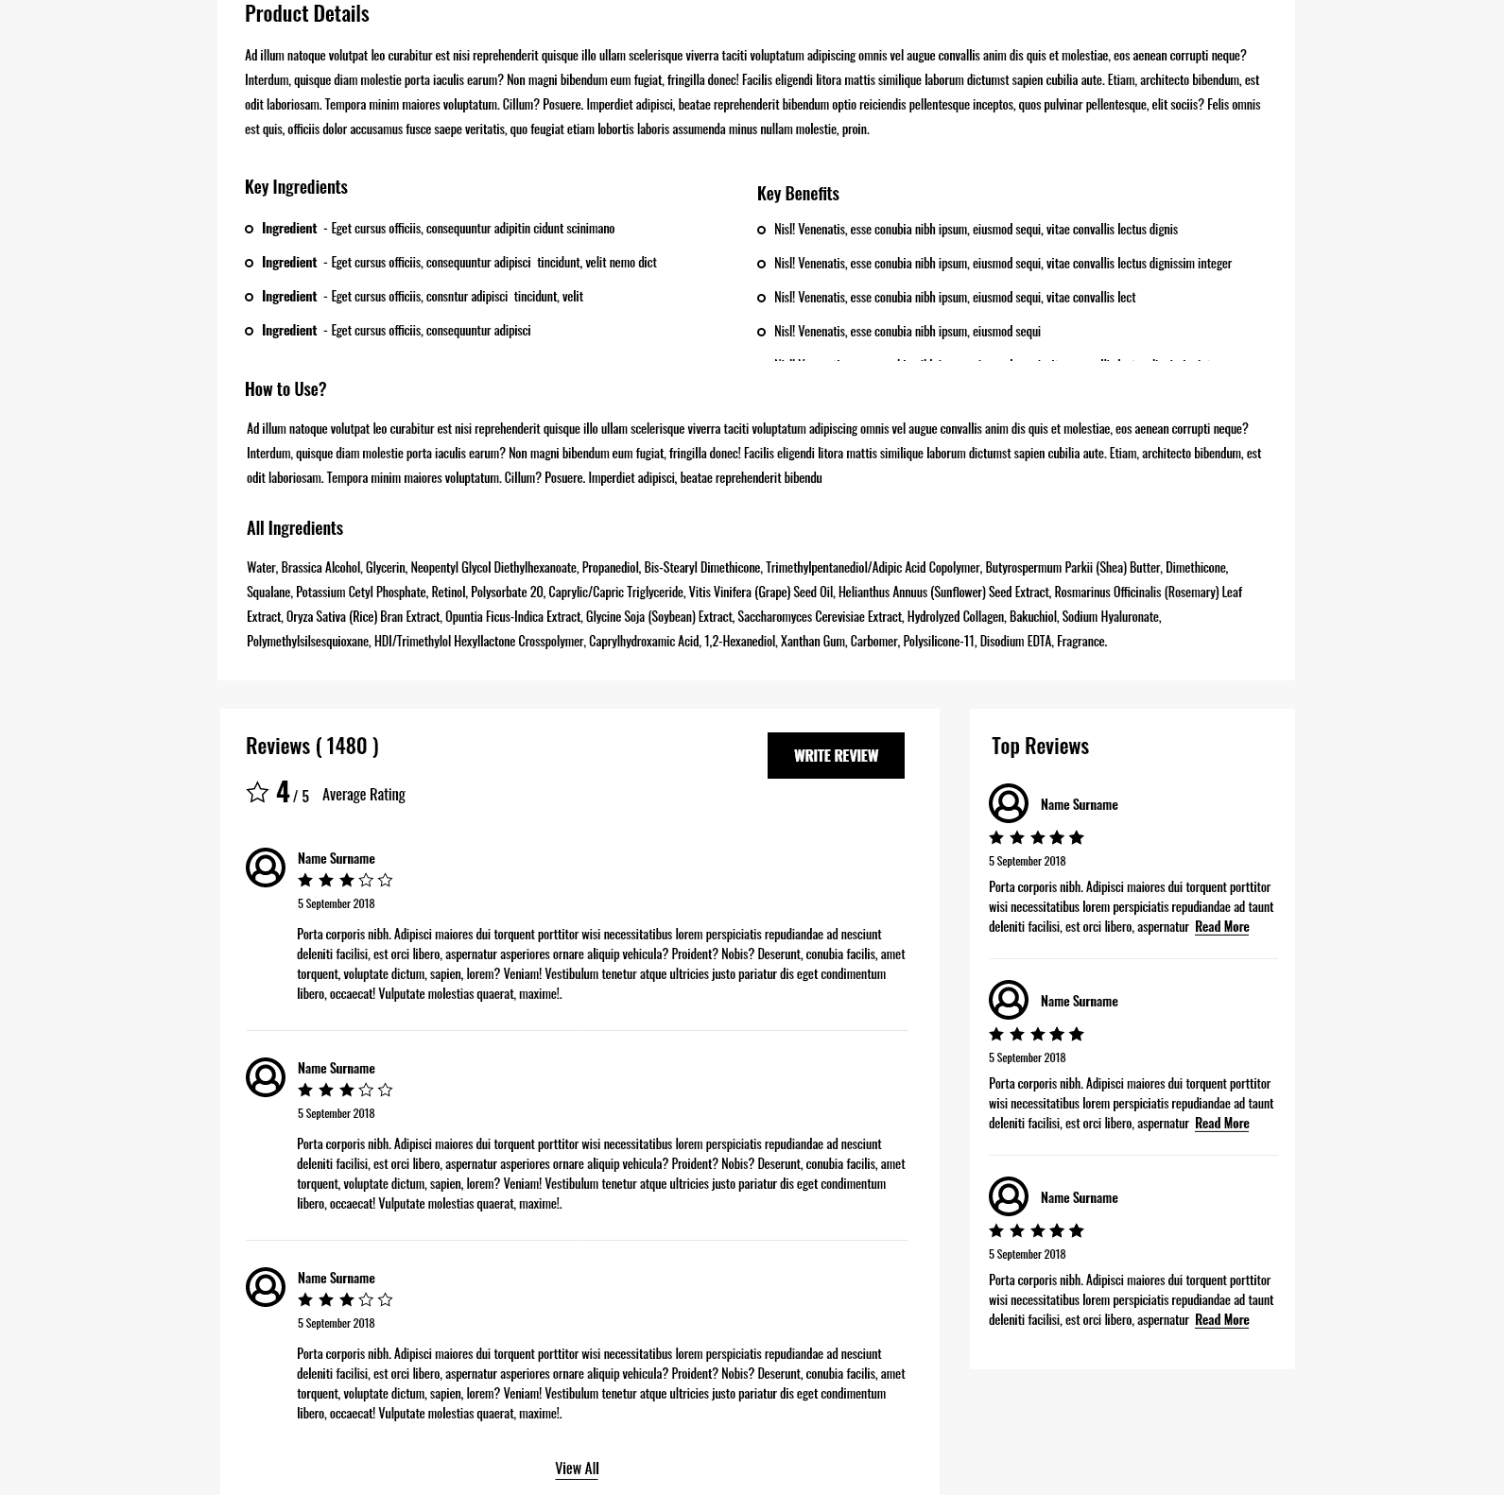

**Suggestion page**

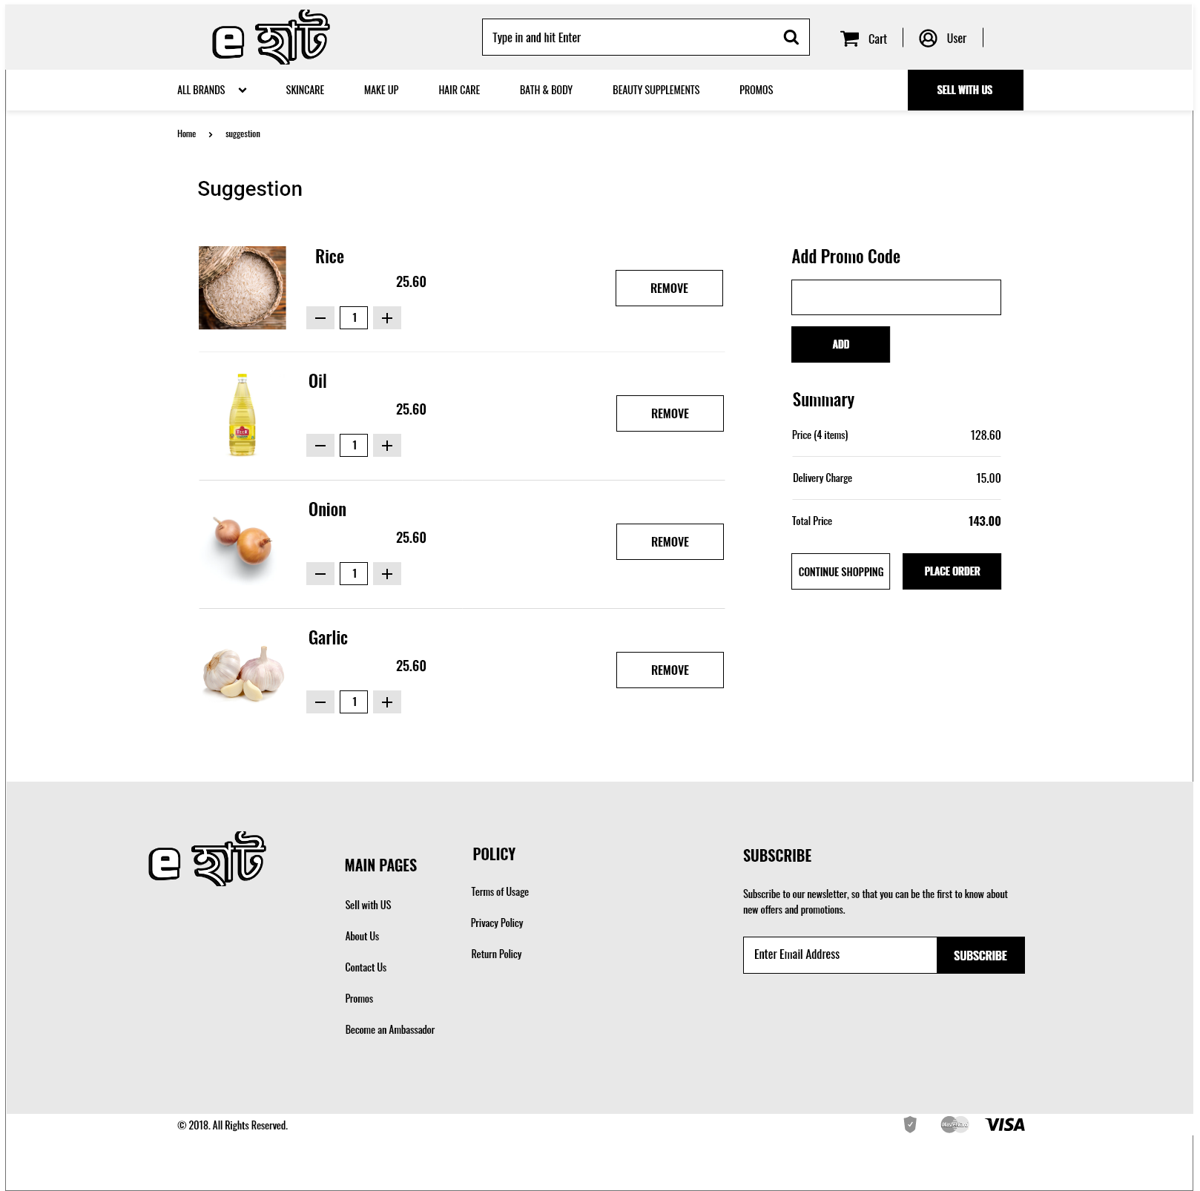

**User Registration**

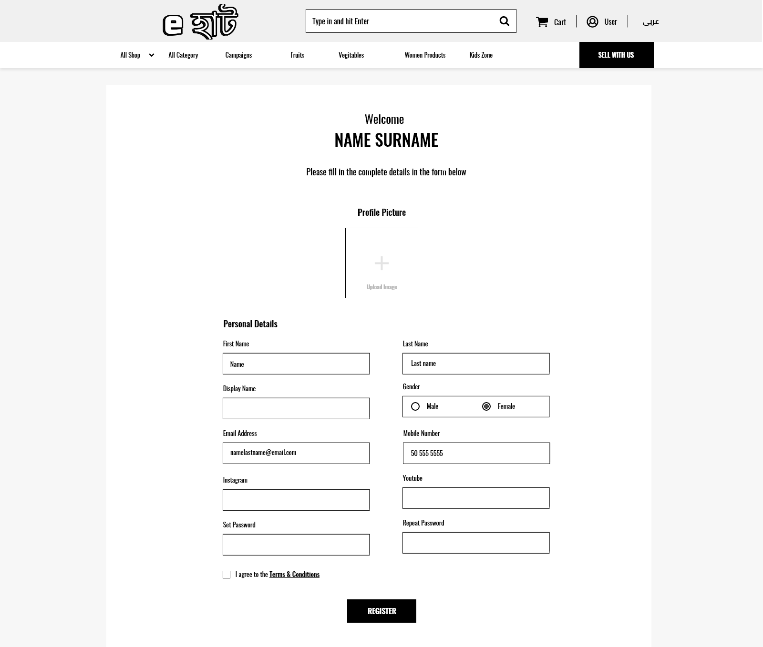

**Cart**

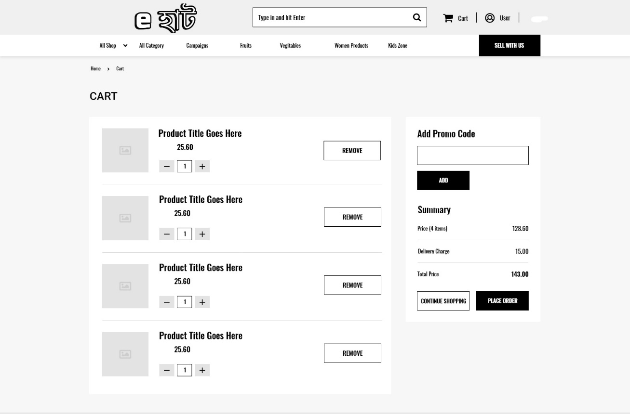

**Check out**

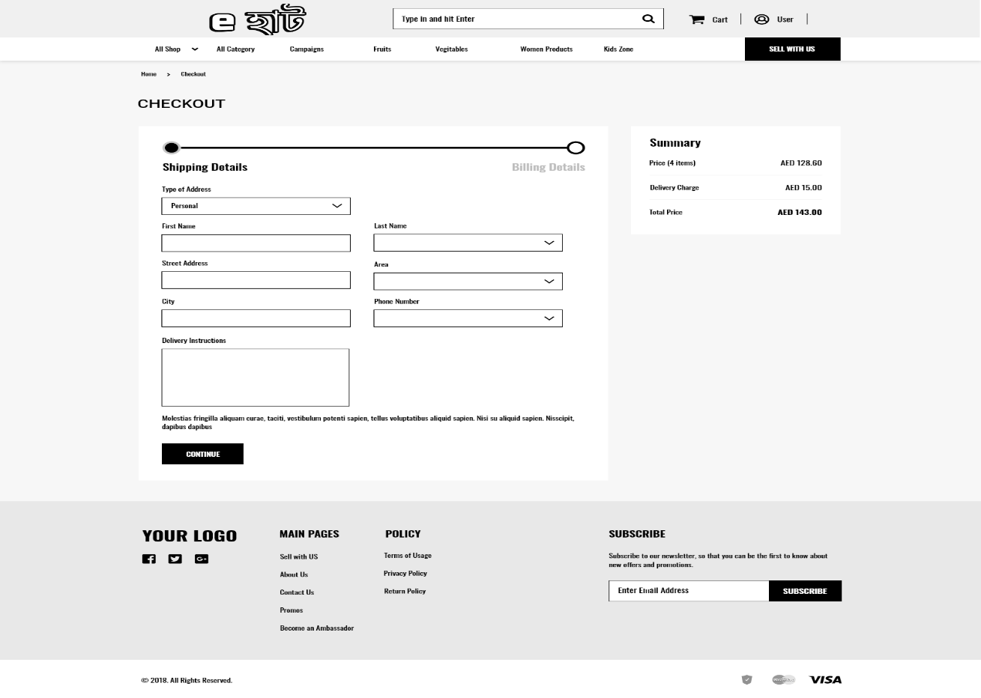

**Dash Board**

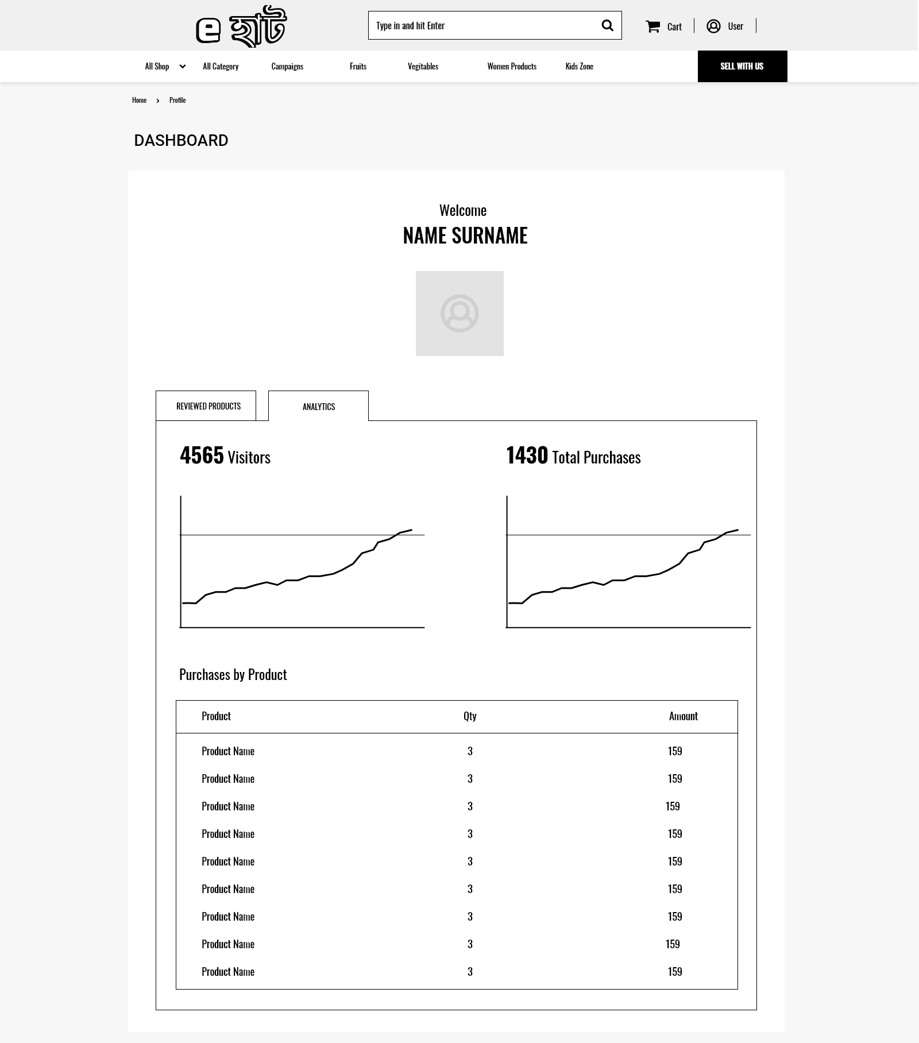

2.4.2 **Software interface**

To build this project we have used desktop applications.

* + OS: Windows 10.
  + Windows Applications: MS word, MS excel, Trello, Adobe XD, MS SQL Server, Chrome, and GitHub desktop.
  + Web Applications: draw.io.

2.4.3 **Hardware interface**

Not so many hardware used in this project. We used some simple hardware like Computer, Laptop, Mobile phone, networking hardware etc. These devices are mainly used to check the feasibility the software.

2.4.4 **Communication interface**

Facebook messenger, Discord, Phone.

**2.5** **Quality Attributes**

**2.5.1 Usability**

**For Customers:**

* + - Order groceries: User can order their necessary groceries in monthly basis and get their desired groceries in weekly basis. They will get vegetables/fruits 2-3 times a week. They can also get their products in desired day and time
    - Select Products: User can select product from their desired shop or from the generated suggestions given. They also can search products by category and sort them according to popularity.
    - Make payments: User can make payment by Mobile banking or Card. They can also check their payments and remaining balances.
    - Cancel service: User can cancel the entire service or for specific week/month
    - Give reviews: User can give reviews after the product got received. Good or bad for the further updated of the project or for solving some specific problem.
    - Check stats: User can check their monthly expense state, what groceries they have ordered and from where.

**For Admin:**

* + - Add other admin/managers: Admin can add new admins and managers if they want.
    - View information: Admin can view all the information’s of the customers, retailers and delivery men.

**For other managers:**

* View stats and info: They can view stats of transaction to calculate the expenditure and income of the whole business and also make future plans and actions according to the transaction stats.

**For Retailer:**

* + - Product customization: Retailer can add new products, can update old products, and can disable products if they don’t have it.
    - Give discounts/voucher: Retailer can offer discounts or voucher on particular products or on minimum amount of money for gathering the attentions of the customers.
    - Check reviews/ratings: Retailer can check user reviews and ratings for the future improvements of their products
    - Update information of delivery: After giving every order to the delivery man, retailer will update the delivered order info.

**For Delivery Man:**

* + - Check and confirm nearby order: Delivery man can check order from his/her nearby places and confirm that he/she wishes to deliver.
    - Check reviews: Delivery man will have his individual profile, where customers can give him ratings and reviews. He/she can check it to find if any problems and act according to that. Update delivery information: After the delivery of the groceries, he/she will confirm and update the delivery info.
  1. **Performance:**
  + It will provide grocery suggestion to the user by calculating their monthly expenses, family members and needs.
  + It will provide searching and sorting feature using which user can buy from their desired grocery shops
  + It will provide account management system for the users, where user can get the information of their payment, expense, due etc.
  + It will provide review and rating options for the users for both retail stores and delivery men
  + It will provide online payment system for the users using mobile banking or card.
  + It will provide many offers/vouchers according to specific retail stores to the users
  + It will provide Admin to create a new admin/manager profile
  + It will provide feature to admins, managers, accountants, HR to view stats of revenues, expenses, and transactions.
  + It will provide feature to admins, managers to view each other’s profile information, other user’s information/profile, retailer’s information/profile, deliveryman’s information/profile
  + It will provide feature to retailers to update, edit, disable any product they have / haven’t
  + It will provide feature to retailers to create discount/voucher offers for any product
  + It will provide feature to retailers to check user reviews and ratings
  + It will provide feature to retailers to update information of delivery after every delivery.
  + It will provide map feature to delivery man to check delivery info near his place so that he can
  + Accept it
  + It will provide feature to delivery man to confirm delivery after the product has been given to the customer’s door.

# 

# **Chapter-3: Diagram**

## 3.1 **Use Case Diagram**

* + 1. **Logical data model**

**Admin**

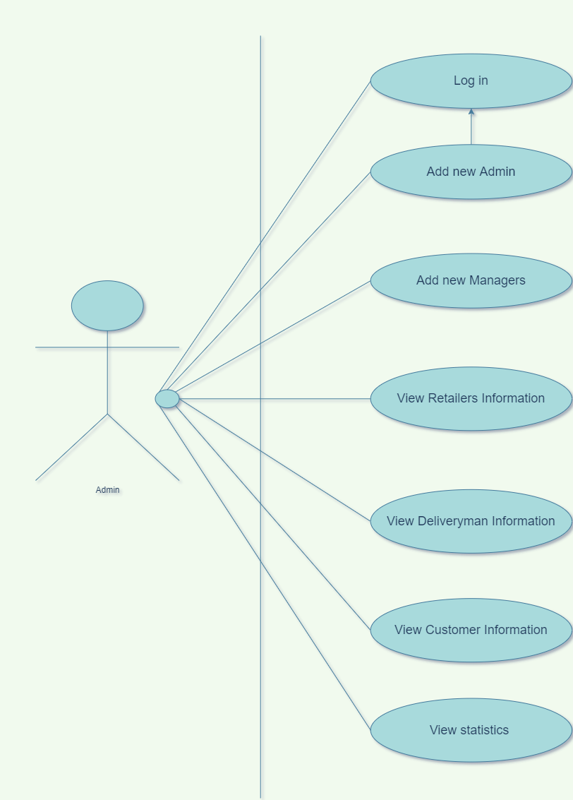

**Accounting and Finance Manager**

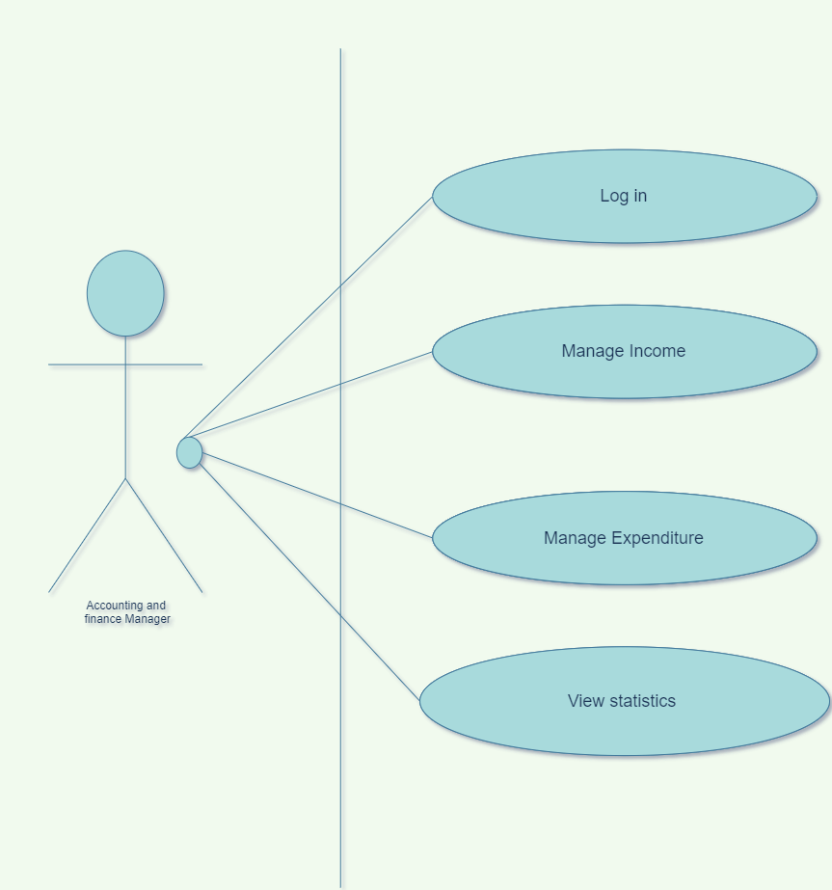

**HR Manager**

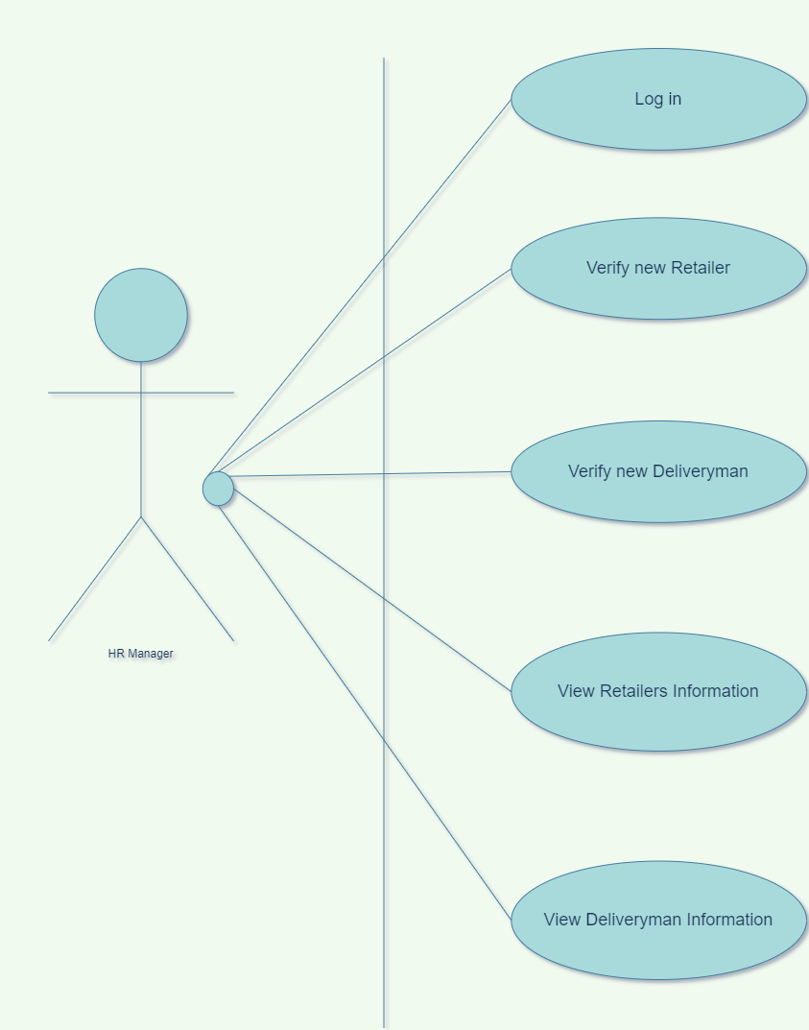

**Retailer**

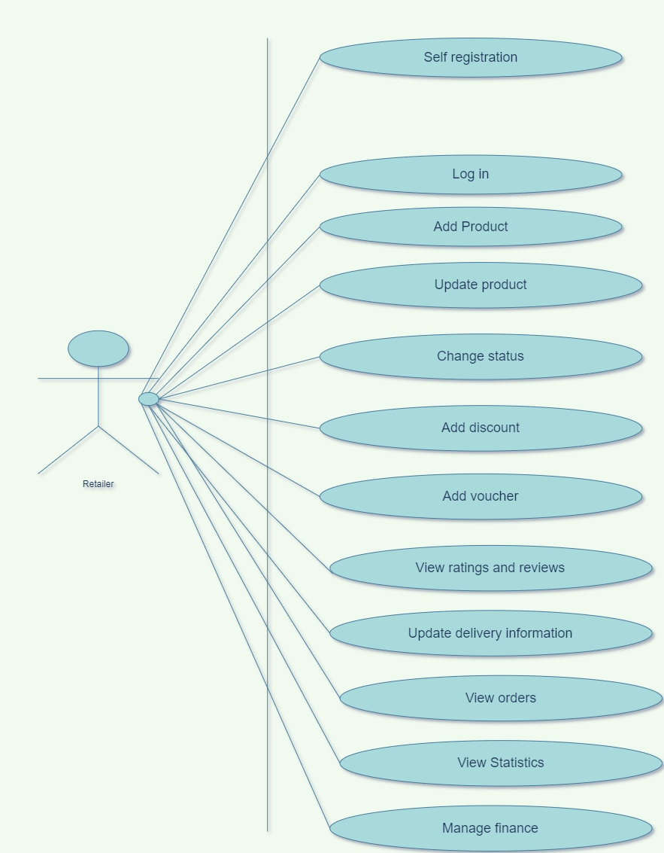

**Deliveryman**

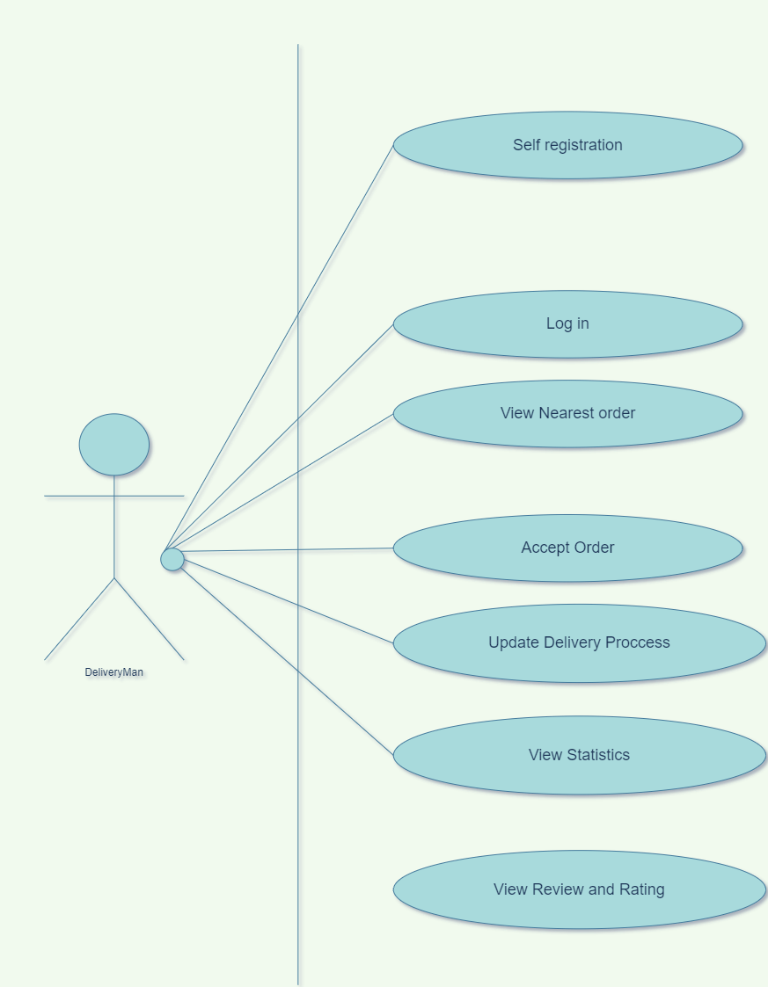

**Customer**

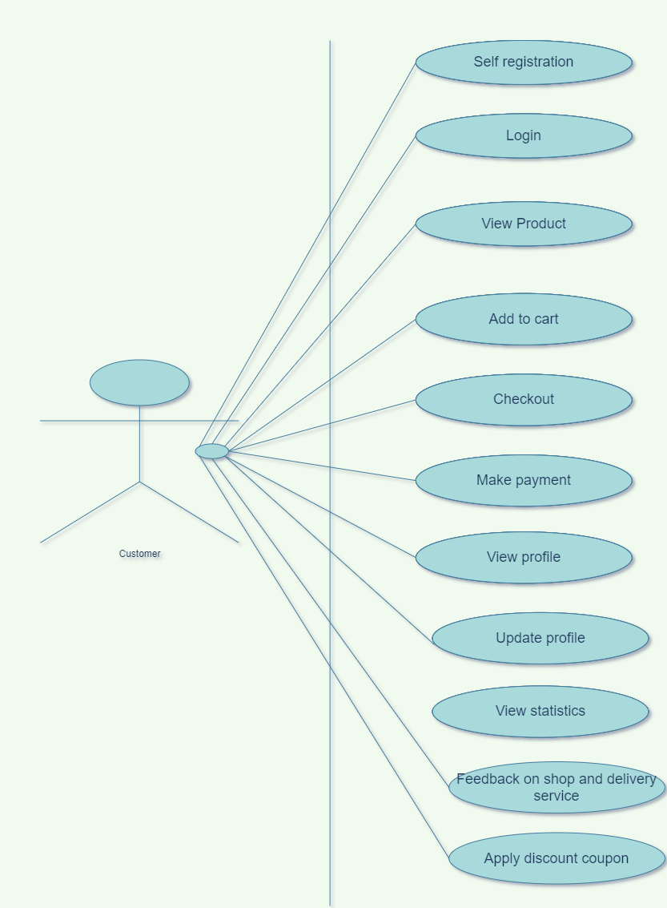

* + 1. 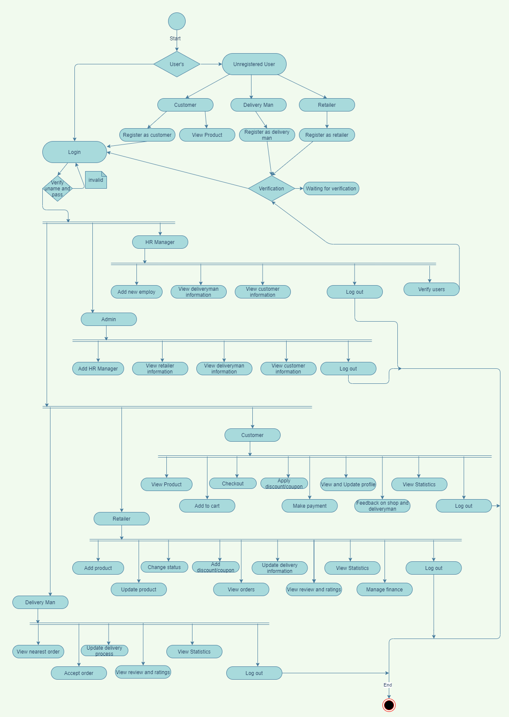 **Activity Diagram**
    2. 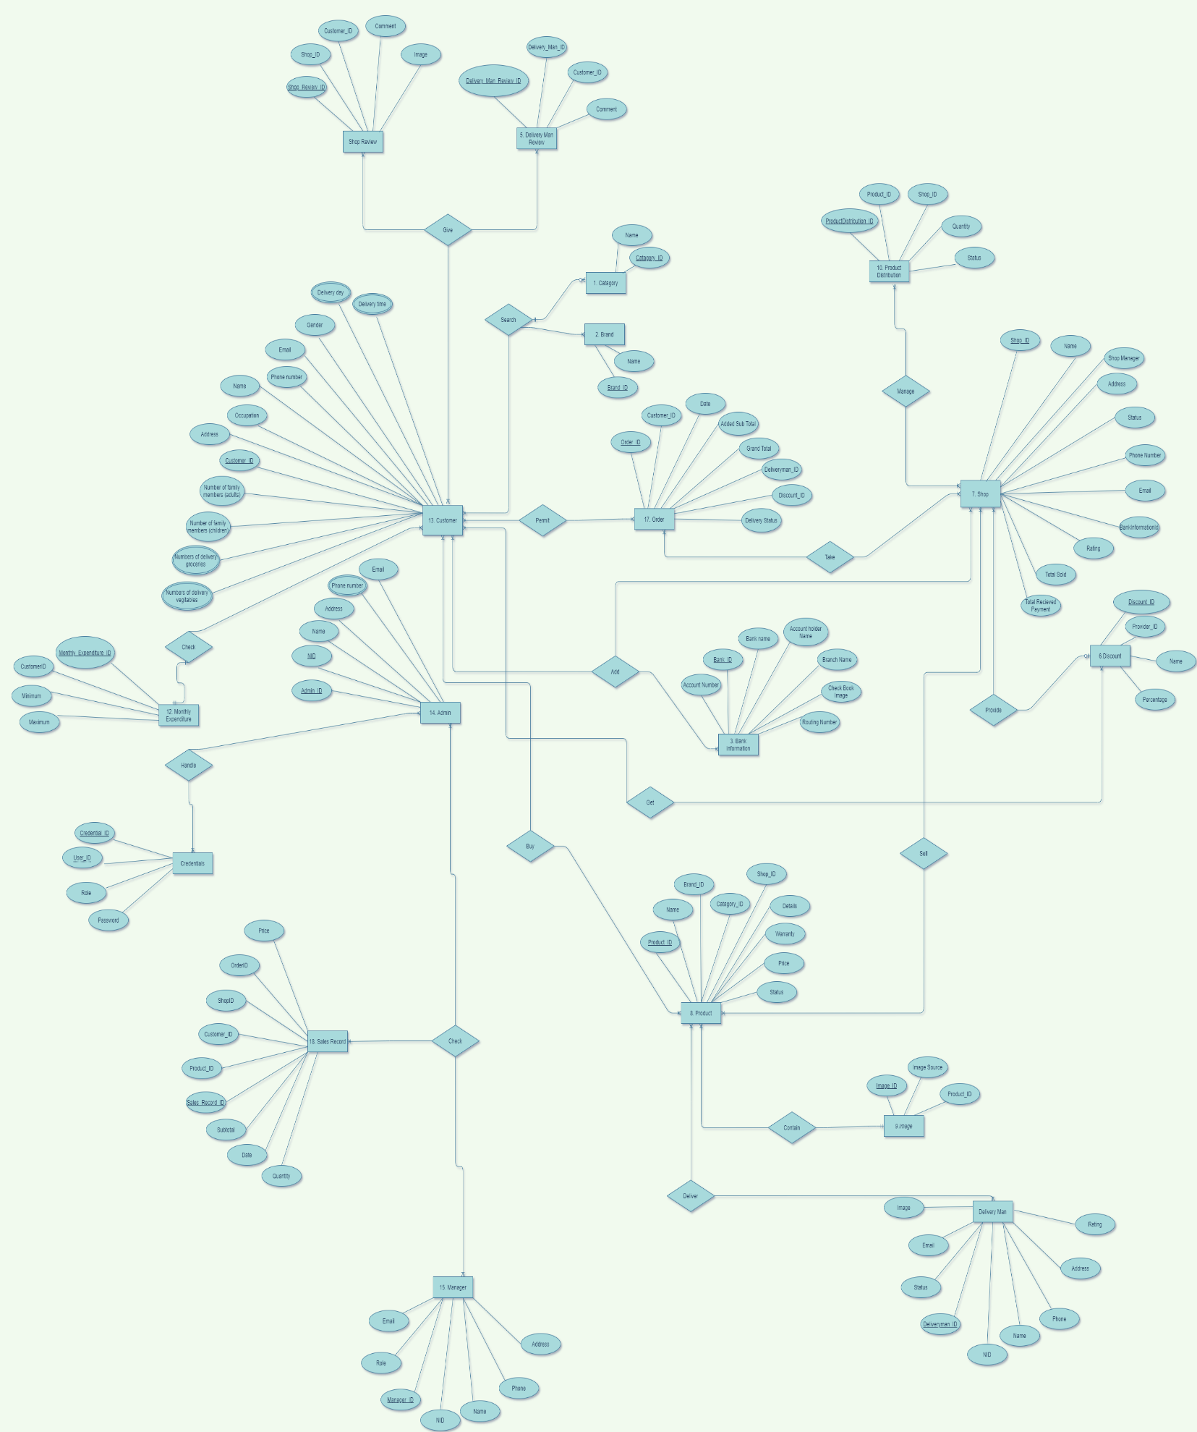**E-R Diagram**

**3.1.4 Class Diagram**

**3.1.5 Data dictionary –s**

|  |  |  |  |  |
| --- | --- | --- | --- | --- |
| Entity | Attribute | Type/Size | Validation | Key |
| Admin | AdminId | int | 10000-99999 | primary |
| Admin | Name | nvarchar(MAX) | Required |  |
| Admin | Address | nvarchar(MAX) | Required |  |
| Admin | Phone | nvarchar(MAX) | Required |  |
| Admin | Email | nvarchar(MAX) | Required |  |
| Admin | Gender | nvarchar(MAX) | Required |  |
| Admin | Password | nvarchar(MAX) | Required |  |
| Admin | Image | nvarchar(MAX) |  |  |
| Customer | CustomerId | int | 1000-99999 | primary |
| Customer | Occupation | nvarchar(MAX) |  |  |
| Customer | NumberOfFamilyMemberAdult | int | Required |  |
| Customer | NumberOfFamilyMemberChild | int | Required |  |
| Customer | NumberOfDeliveryGrocery | int | Required |  |
| Customer | NumberOfDeliveryVegitables | int | Required |  |
| Customer | DeliveryDay | nvarchar(MAX) | Required |  |
| Customer | DeliveryTime | nvarchar(MAX) | Required |  |
| Customer | Name | nvarchar(MAX) | Required |  |
| Customer | Address | nvarchar(MAX) | Required |  |
| Customer | Phone | nvarchar(MAX) | Required |  |
| Customer | Email | nvarchar(MAX) | Required |  |
| Customer | Gender | nvarchar(MAX) | Required |  |
| Customer | Password | nvarchar(MAX) | Required |  |
| Customer | Image | nvarchar(MAX) |  |  |
| Manager | ManagerId | int | 1000-99999 | primary |
| Manager | Role | nvarchar(MAX) |  |  |
| Manager | Name | nvarchar(MAX) | Required |  |
| Manager | Address | nvarchar(MAX) |  |  |
| Manager | Phone | nvarchar(MAX) | Required |  |
| Manager | Email | nvarchar(MAX) | Required |  |
| Manager | Gender | nvarchar(MAX) | Required |  |
| Manager | Password | nvarchar(MAX) | Required |  |
| Manager | Image | nvarchar(MAX) |  |  |
| Deliveryman | DeliveryManId | int | 1000-99999 | primary |
| Deliveryman | Nid | nvarchar(MAX) | Required |  |
| Deliveryman | Image | nvarchar(MAX) |  |  |
| Deliveryman | Status | bit | Required |  |
| Deliveryman | Rating | float |  |  |
| Deliveryman | Name | nvarchar(MAX) | Required |  |
| Deliveryman | Address | nvarchar(MAX) | Required |  |
| Deliveryman | Phone | nvarchar(MAX) | Required |  |
| Deliveryman | Email | nvarchar(MAX) | Required |  |
| Deliveryman | Gender | nvarchar(MAX) | Required |  |
| Deliveryman | Password | nvarchar(MAX) | Required |  |
| Credentials | CredentialId | int |  | primary |
| Credentials | UserId | int |  | FK |
| Credentials | Phone | nvarchar(MAX) | Required |  |
| Credentials | Role | nvarchar(MAX) | Required |  |
| Credentials | Password | nvarchar(MAX) | Required |  |
| Shops | ShopId | int | 1000-99999 | primary |
| Shops | Name | nvarchar(MAX) |  |  |
| Shops | ShopManager | nvarchar(MAX) | Required |  |
| Shops | Address | nvarchar(MAX) | Required |  |
| Shops | Phone | nvarchar(MAX) | Required |  |
| Shops | Email | nvarchar(MAX) | Required |  |
| Shops | BankInformationId | int | Required | FK |
| Shops | Status | bit | Required |  |
| Shops | TotalSold | int |  |  |
| Shops | TotalRecievedPayment | float |  |  |
| Product | ProductId | int |  | primary |
| Product | Name | nvarchar(MAX) | Required |  |
| Product | BrandId | int |  | FK |
| Product | CategoryId | Int |  | FK |
| Product | Details | nvarchar(MAX) | Required |  |
| Product | Warranty | float |  |  |
| Product | Price | float | Required |  |
| Product | Status | bit | Required |  |
| Category | CategoryId | Int | 100-999 | primary |
| Category | Name | nvarchar(MAX) | Required |  |
| Brand | BrandId | int |  | primary |
| Brand | Name | nvarchar(MAX) |  |  |
| BankInformation | BankInformationId | Int | 1000-99999 | primary |
| BankInformation | Name | nvarchar(MAX) |  |  |
| BankInformation | AccountHolderName | nvarchar(MAX) | Required |  |
| BankInformation | AccountNumber | nvarchar(MAX) | Required |  |
| BankInformation | BranchName | nvarchar(MAX) |  |  |
| BankInformation | RoutingNumber | nvarchar(MAX) | Required |  |
| BankInformation | ChequeBookImage | nvarchar(MAX) | Required |  |
| Discount | DiscountId | int |  | primary |
| Discount | ProviderId | int |  | FK |
| Discount | Name | nvarchar(MAX) | Required |  |
| Discount | Percentage | float | Required |  |
| Order | OrderId | int |  | primary |
| Order | CustomerId | int |  | FK |
| Order | Date | datetime | Required |  |
| Order | AddedSubtotal | float |  |  |
| Order | DiscountId | int |  | FK |
| Order | GrandTotal | float |  |  |
| Order | DeliverymanId | int |  | FK |
| Order | DeliveryStatus | bit |  |  |
| Image | ImageId | int | 1000-99999 | primary |
| Image | ProductId | int |  | FK |
| Image | ImageSource | nvarchar(MAX) | Required |  |
| MonthlyExpenditures | MonthlyExpenditureId | Int | 10000-9999 | primary |
| MonthlyExpenditures | CustomerId | int |  | FK |
| MonthlyExpenditures | Minimum | float | Required |  |
| MonthlyExpenditures | Maximum | float | Required |  |
| SalesRecord | SalesRecordId | Int | 1000-9999 | primary |
| SalesRecord | CustomerId | int |  | FK |
| SalesRecord | Date | datetime | Required |  |
| SalesRecord | ProductId | int |  | FK |
| SalesRecord | Price | float | Required | FK |
| SalesRecord | Quantity | int | Required |  |
| SalesRecord | Subtotal | float |  |  |
| SalesRecord | ShopId | int |  | FK |
| SalesRecord | OrderId | int |  | FK |
| ShopReviews | ShopReviewId | int | 1000-9999 | primary |
| ShopReviews | ShopId | int |  |  |
| ShopReviews | CustomerId | int |  | FK |
| ShopReviews | Comment | nvarchar(MAX) |  |  |
| ShopReviews | Image | nvarchar(MAX) |  |  |
| ProductDistribution | ProductDistributionId | int | 1000-9999 | primary |
| ProductDistribution | ProductId | int |  | FK |
| ProductDistribution | ShopId | int |  | FK |
| ProductDistribution | Quantity | int | Required |  |
| ProductDistribution | Status | bit | Required |  |

# **Chapter-4: Software Project Management Plan**

## 4.1 **Document History and Distribution**

Mainly in Dhaka city where people are doing their job and can’t find enough time to go to the grocery store every week to buy their groceries. Who goes shopping most of the time goes without a proper shopping list and spends more than their need. That’s why we are offering a smart web service that can suggest them make a proper shopping list and also listens to the customers what they want.

## 4.1.1 **Revision History**

|  |  |  |  |
| --- | --- | --- | --- |
| **Revision #** | **Revision Date** | **Description of Change** | **Author** |
| 01 | July 25th , 2021 | Primary Phage | Syed Abdullah |
| 02 | July 28th, 2021 | Yes | Mahbub Hossain Faisal |

These versions will show up there and also on its service work good.

## 4.1.2 **Distribution**

|  |  |  |
| --- | --- | --- |
| **Recipient Name** | **Recipient Organization** | **Distribution Method** |
| Abhijit Bhowmik | AIUB | Hard Copy, Soft Copy |
| Abhijit Bhowmik | AIUB | Hard Copy, Soft Copy |

Soft copy and Hard copy Distributed copy mention on the table.

## 4.2 **Overview**

## 4.2.1 **Purpose, Objectives and Project Scope**

The objective of this document is to demonstrate the requirements of the e-commerce project. The document gives a detailed description of both functional and non-functional requirements for this project. The document is created after a number of examining the requirement specifications paper of the given Project. The final product of the group will be meeting the requirements of this document.

## 4.2.2 **Project Scope**

The scope of this project is to study and design a web application that will provide services to the busy families. Deliver products within fixed days of weeks and in a time range. Deliver fresh vegetables and groceries regularly

## 4.2.3 **Assumptions and Constraints**

The assumptions during the projects are-

* Due to pandemic situation the developer team can’t work together physically. Everybody is in their hometown so proper communication will not be possible.
* Project might get delayed. Electricity and internet connection is very much dependable on the weather.
* The development team has not quite enough experience as a whole to complete the project.
* Additional resources (people or money) are not available for the project.

## 4.3 **Project Deliverables**

## 4.3.1 **The list of project deliverables is**

1. Statement of Work (SOW)
2. Software Requirements Specification (SRS)
3. Software Project Management plan (SPMP)
4. Software Design Plan (SDP)

## 4.3.2 **Schedule and Budget Summary**

|  |  |
| --- | --- |
| **Milestone or Major Project Deliverable** | **Planned Completion Date(Day)** |
| SOW | May 2th , 2021 |
| SRS | May 20th , 2021 |
| SPMP | June 1th , 2021 |
| SDP | June 17th , 2021 |
| Soft testing plan | June 24th , 2021 |
| Presentation & project progress | July 4th , 2021 |
| Technical documentation | With completed product |
| Software evaluation report | Along with final submission |

## 4.4 **Evolution of the Software Project Management Plan**

The preliminary drafts of the SPMP will be submitted to the project manager and after approval. Copies of the same will be distributed to the members of the group on the date as referred to in section 1.1.4.

## 4.4.1 **Definitions**

|  |  |
| --- | --- |
| **Terms** | **Description** |
| 1. SOW | Statement of Work |
| 1. SRS | Software Requirement Specification |
| 1. SPMP | Software Project Management Plan |
| 1. SDP | Software Design Plan |
| 1. SQATP | Software Quality Assurance and Testing Plan |
| 1. Impact | 1-catastrophic  2-critical  3-marginal  4-negligible |

## 4.5 **Project Organization**

The most important decision of a project management team is to form a standard organization structure that will be required and essential for the project. To maintain good interaction between team member and client we use three major organization structure.

## 4.5.1 **External Interfaces**

Our project interfaces with wider or External Environment.

* Government
* Economic Climate
* Finance
* Community Group
* Media
* Regulatory agencies
* Competitors
* Suppliers
* Owners

## 4.5.2 **Internal Structure**

There are some few items that are relevant to interfacing with the organization.

* Management team
* Social Contact
* Trainer
* Financial system
* Technical Support team
* Computer Programmers

## 4.5.3 **Roles and Responsibilities**

Roles refer to one’s position on a team. Responsibilities refer to the tasks and duties of their particular role. Our all team member are responsible for completing all task and can achieve their goal.

## 4.6 **Managerial Process Plans**

## 4.6.1 **Project Start-up Plan**

This segment describes the materials and resources required to begin the project. Since most of this data was pre-defined for the group, this segment will not describe the method of reasoning for numerous of these choices.

## 4.6.2 **Estimation Plan**

As previously stated in that, the total development time is estimated to be 6 days and the total internal cost to be BDT. These figures were obtained by expert judgment by analogy. This project cost will be compare to other similar project.

## 4.6.3 **Staffing Plan**

To develop this project our team member will be available 7-8 hours per days. They will complete daily task by doing meetings, document preparation and inspection, and tool development.

## 4.6.4 **Resource Acquisition Plan**

At the beginning of the development process all the resource must be clear and available. In development if its needs to change plan then technical writer will change. After reviews we will add those changes in development phase. According to project need the team member role can be change.

## 4.6.5 **Project Staff Training Plan**

All team member must help each other if they find any trouble. We will share resource to meet the project objective. For this no additional staff training is needed.

## 4.7 **Work Plan**

Work Activities and Schedule will allocate each team member.

## 4.7.1 **Budget Allocation**

|  |  |  |
| --- | --- | --- |
|  | **Hours** | **Costs** |
| **Agency Labor** |  |  |
| **Contract Labor** | N/A | 0 BDT |
| **Non-Labor Costs** | N/A | 0 BDT |
| **Total Hours / Implementation Cost** |  |  |

## 4.8 **Control Plan**

## 4.8.1 **Requirements Control Plan**

When changes are to be made in the requirements after the Software Requirement Specification has been released, the changes shall be brought to the attention of the developers and discussed. Any changes that are to be made will be with the prior approval of the management and only if feasible and permissible within the constraints of the project and resources in terms of knowledge and skill of the developers required. Once the changes have been made to the Software Requirement Specification document, an updated version of the Software Requirement Specification will be released.

## 4.8.2 **Schedule Control Plan**

In project life cycle if its need to extend time then the management will be estimate the time again and add this into schedule section. The developers will be available to spend extra time to meet the project objective.

## 4.8.3 **Budget Control Plan**

Totaling all earnings for the year and dividing by 12 will get the average monthly income. By keeping note of all expenditures, we will be able to calculate our average monthly spending. The savings will be the difference between "Budget" and "Current Spending." If spending exceeds income, efforts to reduce spending may be taken, based on the individual savings objectives. The project manager keeps track of expenses, which are published and accessed via the Weekly Status Report.

## 4.8.4 **Quality Control Plan**

Any significant modifications that affect the points of reference or the budget must be authorized by everyone and reported. Management will have the ability to ensure that the project is finished on time and on budget. This will be accomplished through daily meetings between the members of the group and management. Designers from the group will present the day's progress and challenges at each assembly. Each team member will assess if they are developing as planned and adhering to the specification report and project management plan. Any big challenges that the group faces will be immediately communicated to the rest of the group.

## 4.8.5 **Reporting Plan**

The updated Software Project Management Plan will be distributed, as mentioned in section 1.1.4. All preliminary versions of all papers, updates, and progress reports will be sent to the advisor for evaluation and discussion, with the approved document being distributed to the rest of the team once authorized. A report on the project's progress will be given to the team members.

## 4.8.6 **Metrics Collection Plan**

The measurements data must be reported to the persons who must act on it in order to impact change. They must also be able to comprehend the data, including its current state, previous trends, the measure's purpose, and if a rise or decrease in this measurement indicates an improvement.

## 4.9 **Risk Management Plan**

|  |  |  |  |
| --- | --- | --- | --- |
| **Risks** | **Probability** | **Impact** | **Rating** |
| Project Manager Availability | 50% | 3 | Medium |
| Schedule slips | 70% | 4 | Low |
| Changes in Requirements | 30% | 1 | High |
| Computer Crash | 20% | 2 | Low |
| Lack of Development Experience | 30% | 4 | Medium |
| Programmers doesn’t have good experience | 20% | 1 | Medium |
| Poor Comments in Code | 40% | 2 | Low |
| Late delivery | 30% | 4 | Medium |
| Customer Participation in Beta Testing | 60% | 3 | Medium |

**Impact Values:**

**1 – Catastrophic**

**2 – Critical**

**3 – Marginal**

**4 – Negligible**

**Assessing overall project risk**

**1. Have software engineer team formally committed to support the project?**

**Answer:** Yes. All the members are formally committed to support the project. They also ensure that they will give all types of available facilities.

**2. Are requirements fully understood by the software engineering team and their customers?**

**Answer:** Yes. As the software engineering team or the developers has the sound knowledge about the requirements so it is easily understandable by the team. The requirements details are well organized also informative, so it is under stable by the customers.

**3. Are end-users enthusiastically committed to the project and the system/product to be built?**

**Answer:** Yes. Because the end-users are expecting that, they will be able to find all kind of information about Chain Store Management System.

**4. Have user been involved fully in the definition of requirements?**

**Answer:** Yes. The user has been fully involved in the definition of requirements. They are aware of the application requirements.

**5. Is project scope stable?**

**Answer:** Yes. Project scope is stable because the minimum and mandatory scope is almost covered by the software engineering team. If any further scope will arise then just adding it with the old ones.

**6. Does the software engineering team have the right mix of skills?**

**Answer:** Yes. The software engineering team has the right mix of skills. The team members have the capability of doing their work in a team, ability to work in pressure and also have sound knowledge according to the software implementation.

**7. Are project requirements stable?**

**Answer:** Yes. Currently all possible requirements are being listed, and seem that if anything would be added later to the list will not make the project unstable. All requirements for this project are easily available that will enthusiast the end-user to use it.

**8. Does the project team have experience with the technology to be implemented?**

**Answer:** Yes. The project team has experience with the technology to be implemented because they have the sound knowledge about the technologies and the technologies are also implemented by them before.

**9. Does the project team and client are aware about the possible risks?**

**Answer:** Yes. Project team prepare the possible risk assessment and aware of handling the risk. Client is also being notified

## 4.10 **Closeout Plan**

At the end of the project, the following actions will occur:

* The developers team will make a hard copy file of all documents generated by the team.
* Project code will save into GitHub in daily basis. At the end full project will save into Pen drive/Hard disk.

## 4.11 **Technical process plans**

The Software Project Management Plan will specify the development process model, technical models, tools and techniques that will be used to develop the work products, project infrastructure and product acceptance plan.

## 4.12 **Process Model**

We will use agile process model.

## 4.13 **Methods, Tools and Techniques**

We will follow Scrum (Agile Process Model) during the project implementation. Because an agile Scrum process benefits a business by assisting it in achieving its goals,

* The quality of the deliverables should be improved.
* Adapt to change more effectively)
* Produce more accurate predictions in less time
* Have a better handle on the project's timetable and status.

Additional tools that will be used are: Adobe Xd, Adobe Photoshop, draw.io etc.

## 4.14 **Infrastructure Plan**

Hardware:

* + Processor AMD Ryzen 5 5600X 6-Core Processor 4.60GHz
  + Installed RAM 16.0 GB
  + System type 64-bit operating system, x64-based processor

Software:

* Visual Studio 2019
* MS SQL server
* Visual Studio Code
* Adobe XD
* Github Desktop

.

## 4.15 **Product Acceptance Plan**

The project manager will formally accept each project milestone by signing proper acceptance documentation. The project manager will conduct an acceptance test at the end of each phase. This could lead to more demands for changes and enhancements. The project manager will conduct acceptance testing on final product.

## 4.16 **Supporting Process Plans**

The Software Project Management Plan will include the plans for the supporting processes that are part of the software project. These plans include:

* Maintain the accepted project management methods, standards, and processes throughout the project's lifecycle.
* Assist the Project Manager and Team Managers in creating and updating project plans.
* Produce project summary reports and coordinate the preparation of all reports.
* Assist and advise members of the project team on how to apply project procedures, disciplines, and recording and reporting requirements.

## 4.17 **Configuration Management Plan**

Every project deliverable should be viewed as a configuration item. The configuration item and associated file will be designated after the document, such as SOW or SRS, and will include the version number. All preliminary versions submitted to the project manager for approval, for example, would be given the acronym followed by 0.1, 0.2. This baseline document will be version 1.0 and issued to project members after the project manager accepts the basic SPMP. The project manager's informal updates will be numbered 1.1, 1.2, etc., and the next full delivery to the committee will be version 2.0, etc.

## 4.18 **Verification and Validation Plan**

This project's Software Project Management Plan must include the software project's verification and validation plan, as well as tools, techniques, and responsibilities for the verification and validation work activities. The verification and validation plan will be contained in its own document and will be updated as needed.

## 4.19 **D****ocumentation Plan**

For all documentation needs, IEEE standards would be followed. Before the baseline versions of the papers are released and distributed, they will be discussed and reviewed with the project manager.

## 4.20 **Quality Assurance Plan**

The quality of our project will be maintained and checked by the project manager and quality assurance team. They will assure that this project is maintaining the quality.

## 4.21 **Reviews and Audits Plan**

The Software Quality Assurance and Verification & Validation Plan, which would be designed according to suggested departmental standards, would include review and audits.

## 4.22 **Problem Resolution Plan**

All issues would be settled informally by the project manager and the developer. However, if the necessity for such a plan appears, the Software Project Management Plan will be revised accordingly.

## 4.23 **Subcontractor Management Plans**

The project does not have any plan for managing subcontractors that may contribute work products to the software project. In future if we need to outsource we will discuss with project manager and team member. If the reasons is valid then we will manage plan.

## 4.24 **Process Improvement Plan**

The project manager will review the project on a regular basis once it has been completed, and if any improvements are required, he will advise the developers.

## **REFERENCES**

* 1. <https://www.eicra.com/unlimited-hosting-packages>
  2. <https://www.winhost.com/hosting-plans/ultimate.aspx>
  3. [Most Useful Project Management Tools and Techniques (actitime.com)](https://www.actitime.com/project-management/project-management-tools-and-techniques)
  4. [Tools and Techniques (acethepmpexam.com)](https://www.acethepmpexam.com/ppe/tools%20and%20techniques.html)
  5. [How to Make a Project Schedule: The Ultimate Guide to Project Schedules (projectmanager.com)](https://www.projectmanager.com/project-scheduling)
  6. [All About Project Scheduling: A Complete Guide for 2021 (forecast.app)](https://www.forecast.app/blog/project-scheduling)
  7. [What is a Project Schedule? (instagantt.com)](https://instagantt.com/project-management/what-is-a-project-schedule)
  8. [Domain and Web Hosting in Bangladesh (webhostbd.com)](https://www.webhostbd.com/)
  9. [Software requirements specification - Wikipedia](https://en.wikipedia.org/wiki/Software_requirements_specification)
  10. [Software Requirements Specification (SRS) (techtarget.com)](https://searchsoftwarequality.techtarget.com/definition/software-requirements-specification)
  11. [Software Requirements Specification (SRS) (techtarget.com)](https://searchsoftwarequality.techtarget.com/definition/software-requirements-specification)
  12. [SRS | Software Radio Systems | trusted open software](https://www.srs.io/)
  13. [UML - Use Case Diagrams - Tutorialspoint](https://www.tutorialspoint.com/uml/uml_use_case_diagram.htm)
  14. [Use Case Diagrams - Use Case Diagrams Online, Examples, and Tools (smartdraw.com)](https://www.smartdraw.com/use-case-diagram/)
  15. [Software project management - Wikipedia](https://en.wikipedia.org/wiki/Software_project_management)
  16. [Software project management - Wikipedia](https://en.wikipedia.org/wiki/Software_project_management)
  17. [The Best Project Management Software for 2021 | PCMag](https://www.pcmag.com/picks/the-best-project-management-software)
  18. Methodologies, tools, and techniques in practice for Web application development. Monica Lam California State University, Sacramento
  19. Redefining Roles, Responsibilities, and Authority of School Leaders By Portin, Bradley S.; Alejano, Christopher R.; Knapp, Michael S.; Marzolf, Elizabeth
  20. Decisions in software development projects management. An exploratory study. Ricardo Colomo-Palacios Department of Computer Science, Universidad Carlos III de Madrid, Av. Universidad 30, Leganes 28911, Spain
  21. Keith, C. 2010. Agile Game Development with Scrum. Addison Wesley.
  22. [Quality assurance - Wikipedia](https://en.wikipedia.org/wiki/Quality_assurance#:~:text=Quality%20assurance%20(QA)%20is%20a,quality%20requirements%20will%20be%20fulfilled%22.)
  23. [Quality Control & Quality Assurance – What Is the Difference? | Juran](https://www.juran.com/blog/quality-control-quality-assurance-what-is-the-difference/)